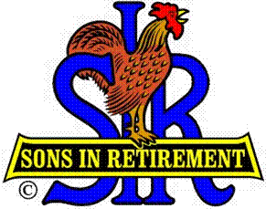
Las Trampas Branch 116
Luncheon Meeting Agenda
June 17, 2019, 11:30 AM

09:30 BEC Meeting
10:30 Social Hour
Greeters – Chuck Vanoncini & Jerry Bennett
Raffle – Mike Yale & Allan Chasnoff
New Member Orientation – (No new members this month)
11:25 Five Minute Call
11:30 Call to order; Opening Remarks – Big SIR
Pledge of Allegiance –
Chaplain – Terry Sherman
Sunshine Report – Matt Arena
11:38 Story Teller – Don Schroeder
11:42 Introduce Speaker –
Guests – Recruitment - Don Schroeder
Recognize Greeters – Jerry - Chuck Vanoncini & Jerry Bennett
11:45 Salad Served
11:46 RAMP Department Heads Reports
11:53 Activity Chair Reports
12:00 Lunch
12:35 Activity Committee Reports (continued if needed)
12:40 Speaker – Susan Wood, Photo Journalist
13:20 Speaker Thank You
13:22 Raffle Drawing -
Birthday Drawing – Little SIR
13:25 Sing Happy Birthday - Music
Sing God Bless America
13:28 Adjourn; Next Meeting, July 15, 2019

